Prayer and Liturgy Policy



|  |  |  |
| --- | --- | --- |
| **Approved by:** | Local Governing Body | **Date:** |
| **Last reviewed on:** | 9th October 2024 | |
| **Next review due by:** | October 2026 | |

**Contents**

1. Aims of Prayer and Liturgy 3

2. Legal Requirements 3

3. What is Prayer and Liturgy? 3

4. The Place of Prayer and Liturgy in the Life of our School and Community 4

5. Expectations for our school community 5

6. Links to other policies 7

**Mission Statement**

**‘Aspiring to be great, through loving and learning, following in the footsteps of Jesus.’**

# 1. Aims of Prayer and Liturgy

At St. Gregory’s Catholic Primary School, we aim to provide quality prayer opportunities to which pupils respond well and participate in. We believe that prayer and liturgy in our school community will provide a variety of opportunities to deepen our relationships with God and develop the following:

* contemplate the mystery of God;
* unite our worshipping community;
* the necessary skills of reverence, contemplation, reflection, interpretation, empathy;
* meditation which will enable our relationships with God to be deepened;

Full participation in our faith will allow us:

* To grow in spiritual, moral, cultural, vocational and liturgical understanding;
* To grow in understanding of our living faith tradition;
* To develop a sense of awe, wonder and inspiration in the person of Christ;
* To examine and reflect upon our own individual faith journeys;
* To develop the skills of prayer and our responses to it and being inspired into action, in line with our mission statement;
* To develop the skills to plan and lead our own acts of prayer.

# 2. Legal Requirements

We acknowledge the legal requirement that there must be a daily act of worship for all

pupils. The act of worship is not designated curriculum time and will not be subsumed under

any part of the curriculum, including religious education.

Worship in this school is more than just a legal requirement. It is an integral part of school life and central to the Catholic tradition.

# 3. What is Prayer and Liturgy?

# What is Prayer?

# Prayer is conversation with God, the angels and the saints.

Prayer should be experienced as a living relationship with God, in and through Jesus Christ.   
All forms of prayer are God’s gift.

# What is Liturgy?

# Liturgy is a communal act in which we praise and worship God.

# Liturgy is the source and summit of the Church’s life and our lives.

# All good liturgies involve the telling of the story of Christ and his Church.

# Liturgy is action and symbol; it speaks to the person, it involves all the senses: sight, touch, sound,

# taste and smell-as guided by the Holy Spirit.

# For the purposes of this policy, Liturgy refers to all acts of Collective Worship held within school.

# 4. The Place of Prayer and Liturgy in the Life of our School and Community

* 1. Organisation of Prayer and Liturgy

An Act of Collective Worship, appropriate for the liturgical season, takes place each day and can be celebrated as a whole school, key stage or class.

Collective Worship throughout the week is usually organised as follows:

|  |  |
| --- | --- |
| Monday | Gospel Assembly led by SLT |
| Tuesday | In-class collective worship- this can include phase/key stage collective worship usually teacher led |
| Wednesday | Wednesday Word and Hymn Practice |
| Thursday | Mass in Key stages/ child led class collective worship in class |
| Friday | Staff prayer in weekly briefing 8:30a.m  Whole school Gifts of God Celebration |

On occasion, school will take part in assemblies, which are not linked to scripture or prayer, such as Safer Internet Day assembly, RSE focus, science assembly or others which are curriculum-linked. These, therefore are not considered an act of Collective worship and so are in addition to this.

Children say the designated prayers at the start and end of each day and a prayers before and after meals (see appendix 1). Classes also say a ‘prayer which should be known’ after the lunchtime prayer.

* 1. Prayers which should be known

To ensure pupils have an awareness of a range of traditional prayers, the Birmingham Diocese have identified prayers which should be known:

|  |  |  |  |  |
| --- | --- | --- | --- | --- |
| * Grace before Meals * Grace after Meals * Morning Offering * Prayer at the End of the day * Our Father * Hail Mary * Sign of the Cross | * Act of Faith, Hope and Love * Glory Be * Prayer to the Guardian Angel * Act of Faith * Act of Love * Eternal Rest * Act of Sorrow (contrition) | * The Angelus * The Luminous Mystery * Prayer to the Guardian Angel * Prayer of St. Richard of Chichester * The Joyful Mysteries | * Prayer of St Francis of Assisi * The Memorare * The Sorrowful Mysteries * The Regina Caeli * The Magnificat * The Glorious Mysteries | * The Diocesan Prayer for Vocations * Hail Holy Queen * The Prayer to the Holy Spirit * Stations of the Cross |

Learning these prayers includes teaching children the meaning, as well as how to pray them. Each year group has a different group of these prayers to focus on.

* 1. **Planning for Collective Worship**

Elements of Collective Worship, which must be used when planning, are:

* Gather – bringing everyone into the holy space (for example by playing music, sitting in a different way/space, lighting candles);
* Listen – sharing scripture to proclaim God’s word (for example by listening to scripture set to music, reading scripture, scripture through actions);
* Respond – responding to God’s word through prayer, action or song (for examples, see Birmingham Diocesan Education Service’s [BDES] ‘Practical Prayer Ideas for the Classroom)
* Mission (previously go forth) – sharing the message of the scripture for people to think about and act upon

There should be a sacred space (prayer table) in every classroom. This should be placed in a prominent position and reflect the current liturgical season. Sacred spaces should be clutter-free and be set up in a manner which inspires prayer. See appendix 2 for BDES guidance for prayer areas.

During liturgy (acts of Collective Worship), a prayer focal point should be created. For example, use of the Altar Table in the hall, appropriately dressed; or using the additional tables in the classroom.

Pupils should develop the skills necessary to plan and lead collective worship with growing independence across the phases. This journey of progression is explicitly mapped out for our staff and pupils. (See appendix 4.)

Staff are expected to model high-quality prayerful acts of Collective Worship and then support and facilitate opportunities for pupils to plan and lead their own. See appendices for BDES planning templates and resource bank.

**Mass**

For Catholics, the Mass is central to practice of the faith. At Mass, the Last Supper is remembered but also recreated. Bread and wine are transformed into the body & blood of Jesus. This belief (transubstantiation) is what distinguishes us from many other Christians. This sacrament is above all others because as members of the Church “we receive the Body of Christ and are increasingly being transformed into the Body of Christ”.1

Mass takes place every week in the school hall and is prepared and led by a class, a school group or staff. The Mass should be prepared a week in advance and sent to the parish priest, who will highlight whether any amendments are to be made.

* 1. Links with the Parish and School Communities

All parents/carers, parishioners and governors have an open invitation to our weekly Masses, and we aim to extend this to our celebration (gifts of God) assemblies. We also invite our school community, including parishioners, to special services, such as our Key Stage Lenten services or our May Procession. We celebrate Our Lord’s Nativity in our Christmas play and carol service- we invite all our school community, including parishioners, to these, through publishing the dates on the school calendar on the website.

# 5. Expectations for our school community

5.1 Pupils

Pupils are expected to:

* Participate enthusiastically in all acts of Prayer and Liturgy
* Be active listeners and action the messages in Collective Worship to the best of their ability
* Take part in the evaluation of liturgy and prayer

Youcat 211

**5.1.1 Faith Leaders**

Faith Leaders are expected to:

* Be role models for the school’s Catholic Ethos
* Be role models for planning, leading and participating in acts of prayer and liturgy
* Be responsible for maintaining and evaluating sacred spaces across the school, including prayer tables in classes, feeding back to the Principal or Vice Principal when needed
* Take notice of and act upon areas for improvement, in conjunction with the Principal and Vice Principal
* Take an active part in all other areas of prayer and liturgy across the school, when required

5.2 Parents and carers

We ask that parents and carers support the importance of Prayer and Liturgy by:

* Attended and participating in Masses, assemblies and services where possible
* Support children in practising their readings, when applicable
* Where applicable, attend sacramental Masses of commitment
* Help the school evaluate the effectiveness of prayer and liturgy by completing surveys when available
* At home, where appropriate, support children to access and understand prayer.

5.3 Staff

We ask that staff support the importance of Prayer and Liturgy by:

* Be role-models in attending and actively participating with reverence in acts of Prayer and Liturgy
* Lead high-quality prayer and liturgy, which act as excellent exemplars from which pupils are able to plan their own
* Support pupils in planning and leading acts of prayer and liturgy
* Provide pupils with meaningful prayer and liturgy experiences, including appropriately supporting those with SEND
* Assist pupils to develop the language of prayer and liturgy
* Teach pupils the traditional prayers of The Church (as identified by Birmingham Diocese)

5.4 Subject leader and Senior leadership team (SLT)

The R.E. subject leader, in liaison with The Principal will be responsible for:

* Formulating and reviewing a written Prayer and Liturgy policy
* Coordinating rotas, timetables etc. for acts of prayer and liturgy, including collective worship
* Monitoring the appropriateness and effectiveness of prayer and liturgy, including collective worship
* Providing training to new staff and/or where training needs are identified
* Ensuring that prayer and liturgy takes account of the religious and educational needs of all who share in it and is rooted in the Catholic teachings
* Liaise with the Parish Priest and the Parish Secretary with regard to the preparation and celebration of liturgy, prayer and Mass
* Ensure appropriate risk assessments are in place for religious visits, including visiting church
* Assisting Governors, including the R.E. link governor in carrying out their legal responsibilities with regard to prayer and liturgy

5.5 Governors

The local governing board will:

* Review this policy and ensure it is appropriate for our school’s context
* Place the highest priority on the evaluation of the quality and impact of prayer and liturgy
* Ensure prayer and liturgy is embedded in the school’s cycle of self-evaluation and planned improvements.
* Ensure provision for prayer and liturgy is prioritised when setting budgets and allocating resources

# 6. Links to other policies

This policy is linked to our:

* Religious Education policy

Appendix 1

**Daily Prayers**

**Grace Before Meals** *(to be said before children are dismissed for lunch)*

Bless us, O God, as we sit together.

Bless the food we eat today.

Bless the hands that made the food.

Bless us, O God.

Amen.

**Morning Prayer** *(to be said during morning registration)*

Father in heaven, you love me,

you are with me night and day.

I want to love you always

in all I do and say.

I’ll try to please you, Father,

bless me through the day.

Amen.

**Prayer at the end of the day***(to be said before children are dismissed for lunch)*

God our Father, I come to say

thank you for your love today.

Thank you for my family

and all the friends you give to me.

Guard me in the dark of night

and in the morning send your light.

Amen.

**Grace after meals** *(to be said during afternoon registration)*

Thank you, God, for the food we have eaten.

Thank you, God, for all our friends.

Thank you, God, for everything,

Thank you God.

Amen.

Appendix 2

**BDES Guidance for Prayer Areas-***. each classroom has a box of religious objects for prayer tables. Battery candles only to be used.*

**Prayer Areas**

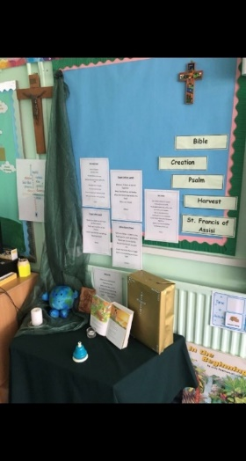Position the prayer areas as a focal point of the room.

**EYFS & Key stage 1** children should be able to gather around the prayer area.

**Key Stage 2** children should be able to easily face towards the prayer area.

Permanent items in a prayer area should include a crucifix, a Bible and a candle. You may also include a religious statue.

Ensure that an age appropriate Bible/Bible story is enthroned upon the table.

Prayer areas can display prayers of the Church at different times of the liturgical year. (The specific prayers the children are learning)

You could include opportunities for children to share their own prayer intentions in a box, basket or book etc.

The area should reflect other key events, commemorations and celebrations of the Liturgical Year Church at appropriate times e.g. during the month of October a statue of Mary or Rosary Beads can be placed.

Additional items may include images, quotes, poems, hymns, Catholic religious symbols and other objects reflecting seasonal prayer intentions of the Church e.g. harvest and creation.

|  |  |
| --- | --- |
| Related image | Related image |
| * Involve children to help create the area. * Ask a colleague to come and view your prayer area to offer guidance and support. * Ensure you know when the Liturgical times of the year change and you know where the appropriate cloth is. * Change the items on the table to match the liturgical seasons. | * Place the prayer area in a place where it is likely to be brushed against/damaged. * Place religious symbols and iconography pertinent to other faiths - This is a Catholic prayer area. * Have all the prayers for the whole year up. * Clutter your prayer area – Sometimes less is more. |

**Liturgical Colours for Prayer Areas**

|  |  |
| --- | --- |
| Advent - Purple | **4 weeks of Advent (Four Sundays before Christmas)**  • Prayer areas during this season will be covered with a purple cloth and should include an Advent Wreath (to be lit at prayer time), an Advent Calendar (counting the days from the first day of Advent to Christmas), figures of Mary & Joseph waiting in the stable, journeying Wise Men and a Jesse Tree (Y4).  An image of Mary on the Diocesan Feast of the Immaculate Conception may also be displayed on 8 December. |
| Christmas - White and Gold | **Christmas Season from the Vigil Christmas Eve Mass until the Feast of the Baptism of the Lord.**  • During the season of Christmas, prayer areas should be adorned in white and gold cloths to celebrate the birth of Christ. Flowers may also be placed in the prayer space (a Poinsettia has significant symbolism) . The crib would include a star, the figures of the nativity and then finally the Wise Men on Epiphany (6th January).  • Symbols of baptism (cross, white garment, oil, water, light) may also be included on the Feast of the Baptism of Our Lord. |
| Ordinary Time 1 Green | **Ordinary time after the Feast of the Baptism of the Lord until Shrove Tuesday (Pancake day!)**  • During this period of Ordinary Time, prayer areas will be covered in a green cloth. The figures of Mary, Joseph and Jesus in the crib can remain until February 2nd (The Presentation of Our Lord) and new candles which may have been blessed at Mass on this date may also be added. |
| Lent – Purple    Holy Week- Purple | **Lent - beginning on Ash Wednesday until the Vigil Mass on Easter Saturday Evening.**  • In the season of Lent, the prayer area will be covered in a purple cloth. A 40 Days calendar to represent the time Jesus spent in the desert may also be added. Sand and stones could be used to recreate the emptiness of the desert. A bowl of ashes on the prayer space would serve as reminder of the ashes placed on the forehead on Ash Wednesday, the start of this season.  The Diocesan Feast of St. Chad is March 2nd, a St. Chad’s Cross could be added to the prayer area to celebrate this Feast Day.  • During Holy Week the prayer area will continue to be covered in purple cloth and palm crosses may be added on Palm Sunday. Images of the Stations of the Cross could be added as a reminder of the events of Jesus’ arrest to his death. A crucifix should also be included as a reminder of Jesus’ crucifixion on Good Friday. Symbols of Holy Week could also be added to the prayer space. |
| Easter Season -  White and Gold  Pentecost-Red | **Easter Season from Easter Sunday until Pentecost (The birthday of the Church)**  • During the season of Easter, the prayer area should be adorned in white and gold cloth as a celebration of Jesus’ resurrection on Easter Day. An Easter Garden could be added as a joyful reminder of the empty tomb which was discovered signifying Christ’s resurrection on Easter Sunday. The word ‘Alleluia’ should feature prominently as a reminder that Christ is risen. Images of the risen Christ as well as a Risen Jesus crucifix would be appropriate. Flowers and symbols of new life including eggs would also celebrate this joyful time. Year 1 in particular should include a Paschal Candle/Easter Candle and lit to signify the light of Christ.  • An image of the Ascension could be displayed on the Feast of the Ascension.  • A statue or image of Our Lady for May, the month of Mary could be added.  • On the Feast of Pentecost, the priest’s vestments and cloths in church will be red. Symbols of the Holy Spirit (dove, wind, fire) could be displayed. This is the church’s birthday and therefore sharing birthday cake would be a joyful sign of this. Images of Pentecost could be used on prayer areas. |
| Ordinary Time 2 - Green | **Ordinary Time following Pentecost Sunday until the Solemnity of Christ the King (the Sunday before Advent begins).**  • During this second period of Ordinary Time, the prayer area would be covered in a green cloth. • Images of Our Lady for her birthday (9th September) could be displayed.  • During the Harvest festival celebrations, objects of creation and offerings for the harvest festival could be displayed on the prayer area.  • In the month of October, images of the Mysteries of the Rosary and Rosary beads can be displayed and used in prayer time.  • Images of the saints on November 1 (the saint of the school or class saint names if relevant) could be displayed.  • During the month of November (the Month of the Holy Souls), a book of prayer intentions could be included for those who have died.  • Images of Christ the King could be displayed on this Feast Day, the week before Advent begins which is also National Youth Sunday. |

**Appendix 3**

**Planning for Collective Worship**

*A number of useful resources can also be found in the staff planning area through SharePoint, such as: Practical Prayer Ideas for The Classroom booklet, useful websites, Practical Prayer Ideas booklet. Staff can also utilise school’s Ten:Ten subscription.*

**Liturgy Planner**

|  |  |
| --- | --- |
| Date: |  |
| Liturgical Season/Feast |  |
| Key Stage/Year Groups |  |

*[When are we celebrating? Who will be celebrating? Where will we celebrating?* Environment]

|  |  |
| --- | --- |
|  | **Resources/ Additional Information [**Which ministries are needed? What needs to be prepared?] |
| **Gathering** [To become a gathered assembly. To prepare us to participate—to listen and respond] |  |
| **Listening** [Participating in the Word of God (readings from scriptures, singing the psalms), is common to all Catholic worship.] |  |
| **Responding** [Our response can be made up silence, reflection, prayer, symbolic action or song.] |  |
| **Mission/Going Forth [**In our liturgical celebrations we offer praise to God; we are also strengthened in our mission to live as Christ in the world.] |  |

**Child-Led Planning Template**

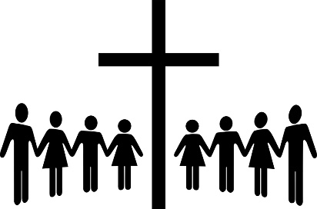

Gather

Listen

Respond

Go Forth

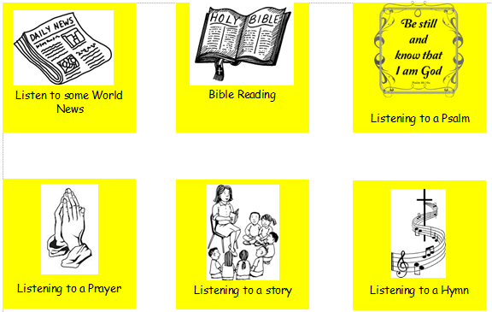

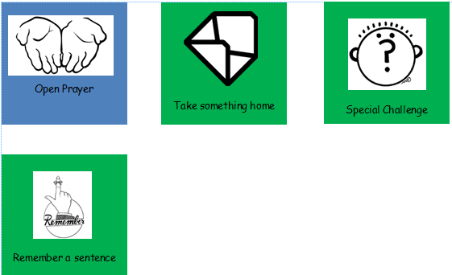

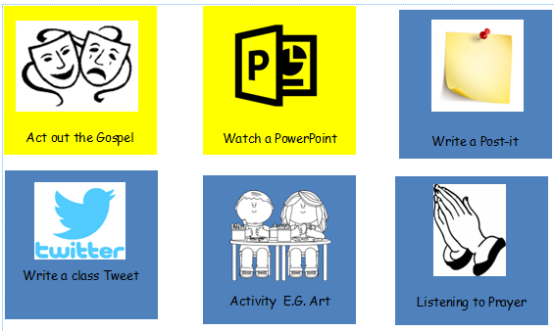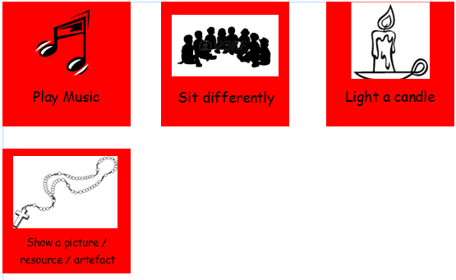

**Appendix 4**

St Gregory’s Catholic Primary School

Planning and Leading Collective Worship

Progression

|  |  |  |
| --- | --- | --- |
| Year Group | Provision | Faith Leader Teams |
| EYFS | **Adult-Led Worship**  Teacher to explicitly model high-quality in-class collective worship during Autumn 1.  Using the child-led planning sheet (see Appendix 3), adults give children (whole class, group and/or individual) two activities from each of the four elements (G, L, R, GF) to choose from. This increases throughout the year until children are choosing from all options and they begin to suggest their own activity ideas.  Throughout the academic year, children become more confident/independent in creating the prayer focal point.  This develops into being able to self-choose appropriate religious objects, including consideration of the liturgical season (with adult guidance)  The teacher plans and coordinates all Masses and class assemblies, distributing scripture, prayers etc. to children. | YR and Y1 Faith Leaders (“FL”) will explore their role by attending FL meetings, closely supported by faith leaders from older classes and the Subject Lead. They will input into class collective worship by feeding back from/into FL meetings, with support. They will be responsible for looking after prayer areas and resources within their classroom. They will try to be collective worship role models in their class. |
| Year 1 | **Adult-Directed Worship** (i.e. adults lead planning with child input and then direct children in leading)  Teacher to explicitly model high-quality in-class collective worship during Autumn 1.  Using the child-led planning sheet (see Appendix 3), children (whole class, group and/or individual) choose activities from each of the four elements (G, L, R, M). Children are encouraged to suggest their own activities *(adults could use the Practical Prayer Ideas for The Classroom booklet to inspire)* so that by the Spring Term, they are confident in doing this mostly independently.  Children lead different elements of the Collective Worship session as directed by an adult. At the beginning of the academic year, each element (G, R, L, M) will be focussed on for children to lead and understand how to do so appropriately *(e.g.: Spring 1 may be a focus on the ‘Respond’ element and the teacher ensures children truly understand how to proclaim the word of God)* Children should be given sufficient time to practise.  The teacher plans and coordinates all Masses and class assemblies, distributing scripture, prayers etc. to children. |
| Year 2 | **Adult-Directed Worship** (i.e. adults facilitate planning and then direct children in leading)  Teacher to explicitly model high-quality in-class collective worship during Autumn 1.  Using the child-led planning sheet (see Appendix 3) and adult-selected focus, children (whole class, group and/or individual), with direction *(e.g.: if the child plans to play music for the ‘Gather’ section, the adult selects the specific hymn/song)*, plan the Collective Worship session for each of the four elements (G, L, R, M). Children use a combination of the planning template-suggested activities and their own *(adults could share the Practical Prayer Ideas for The Classroom booklet to inspire)*.  Children lead all elements of the Collective Worship session as co-ordinated by an adult. Children should be given sufficient time to practise.  The teacher plans and coordinates all Masses and class assemblies, distributing scripture, prayers etc. to children. Through teacher-facilitated discussion, children begin to contribute towards planning. | Y2 Faith Leaders will play an active role in class worship opportunities. They will contribute to the development of these opportunities by feeding back from/into FL meetings. They will be responsible for looking after prayer areas and resources within their classroom and begin to make choices about the resources to be used. They will try to be collective worship role models in their class. |
| Year 3 | **Child-Led Worship** (with adult support in planning and delivery)  Teacher to explicitly model high-quality in-class collective worship during Autumn 1.  Using the child-led planning sheet (see Appendix 3) and adult-guidance for the focus, children (whole class, group and/or individual), with support *(e.g.: if the child plans to play music for the ‘Gather’ section, the adult helps to identify the specific hymn/song)*, plan the Collective Worship session for each of the four elements (G, L, R, M). Children use a combination of the child-led planning template-suggested activities and their own *(adults share the Practical Prayer Ideas for The Classroom booklet to inspire)*. Adults model making planning choices that are linked to the chosen scripture and justifying these choices  Children lead all elements of the Collective Worship session, supported by an adult. Children should be given sufficient time to practise.  The teacher plans and coordinates all Masses and class assemblies, distributing scripture, prayers etc. to children. Through teacher-facilitated discussion, children begin to contribute towards planning. | Y3 Faith Leaders will play an active role in class worship opportunities by modelling leadership for other pupils. They will proactively contribute to the development of these and other opportunities by feeding back from/into FL meetings and overseeing development (with support). They will be responsible for looking after prayer areas and resources within their classroom and making choices about the resources to be used. They will be collective worship role models in their class |
| Year 4 | **Child-Led Worship** (with adult support in planning)  Teacher to explicitly model high-quality in-class collective worship during Autumn 1.  Adults decide the theme of worship opportunities and support children in deciding upon relevant scripture. Children work independently at the planning stage, but prior to delivering their worship opportunities (or during planning), their planning is checked/directed to ensure its relevance to the chosen scripture and theme. Where possible, children will share worship opportunities with other classes in different locations around school and beyond. Pupils will record worship opportunities by completing planning pro forma (starting with child-led planning template and moving onto main planning pro forma)  The teacher plans and coordinates all Masses and class assemblies, distributing scripture, prayers etc. to children. Through teacher-facilitated discussion, children increase their contribution towards planning. | Y4 Faith Leaders will play an active role in class worship opportunities by modelling leadership for other pupils as well as beginning to support others when leading. They will proactively contribute to the development of these and other opportunities by feeding back from/into FL meetings and overseeing development. They will be responsible for looking after prayer areas and resources within their classroom and making choices about the resources to be used. They will be collective worship role models in their class. |

|  |  |  |
| --- | --- | --- |
| Year 5 | Child-Led Worship (with adult support)  Teacher to explicitly model high-quality in-class collective worship during Autumn 1.  Children plan mostly independently are able to justify their planning choices when challenged to do so. Creativity is encouraged. Adults may help to direct more complex parts of worship, such as questioning, so as to ensure themes are explored in depth. Where possible, children will share worship opportunities with other classes in different locations around school and beyond. Pupils will record worship opportunities by completing main planning pro forma  The teacher plans and coordinates Masses and class assemblies, distributing scripture, prayers etc. to children. Through teacher-facilitated discussion, children further increase their contribution towards planning. | Y5 Faith Leaders will play an active role in class worship opportunities by supporting other children when planning and leading worship. They will proactively contribute to the development of these and other opportunities by feeding back from/into FL meetings, overseeing development and suggesting next steps. They will be responsible for looking after prayer areas and resources within their classroom and making choices about the resources to be used, as well as supporting children from younger classes in the development of their prayer areas. They will be collective worship role models in their class |

|  |  |  |
| --- | --- | --- |
| Year 6 | Child-Led Worship (independent)  Teacher to explicitly model high-quality in-class collective worship during Autumn 1.  By the end of Year 6, most children will be able to plan and deliver creative liturgy and other worship opportunities independently, including selection of a liturgically-relevant theme and scripture. Their choice of supporting resources and artefacts will show creativity and resourcefulness, underpinned by liturgical awareness. They will be able to justify their planning and choice of activities by linking these to their chosen scripture – and make this explicit during delivery (e.g. “We have chosen to display the symbol of the dove because...”).  In addition, more able children will be able to:   * lead meaningful, structured discussion of scripture, etc. independently, seeking contributions from their peers and responding to these in a meaningful way. * Be particularly creative and resourceful in their planning of worship opportunities. * Support peers and younger children in planning worship. * Help evaluate collective worship opportunities and make suggestions for future developments. * Have considered what collective worship might be like in their future, beyond primary school, and have ideas about how they might wish to pursue it.   The teacher plans and coordinates Masses and class assemblies, distributing scripture, prayers etc. to children. Through teacher-facilitated discussion, children contribute towards planning. | Y6 Faith Leaders will play an active role in class worship opportunities by supporting other children (across the school when possible) when planning and leading worship. They will contribute to the development of these opportunities by collaboratively deciding the agenda for FL meetings, monitoring development at whole school level and suggesting ways to implement next steps. They will be responsible for looking after prayer areas and resources within their classroom, suggesting new resources to be used, as well as supporting children from younger classes in the development of their prayer areas.  The Y6 FL will play a proactive role in planning, setting up for and delivering whole school worship opportunities. They will be exemplary and prominent role models in all forms of collective worship. They will have responsibility for gathering and recording child and adult feedback after worship opportunities. They will contribute to and influence whole school worship development through regular contact with SLT, including working with the subject leader in developing new worship ideas. At some points during the year, Y6 FL will join worship opportunities across the school, conduct pupil voice questionnaires and contribute to the monitoring and evaluation of worship and action plan for the next school year. |